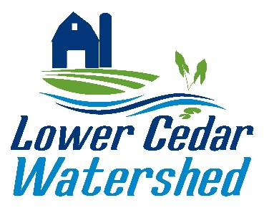

Lower Cedar Watershed Management Authority
Executive Committee Meeting

Meeting: 3pm, Tuesday, April 15, 2025
Location: Zoom meeting
Digital Option: Zoom link to join.
https://us06web.zoom.us/j/89236480585

Agenda:
- Call to order

- National Geographic Freshwater Storytelling Grant Letter of Support (Action Item)

- Heartland / LCWMA Contract Extension Discussion

- Adjourn

